**Thevenin Circuit Practice Questions**

Eg:1 )

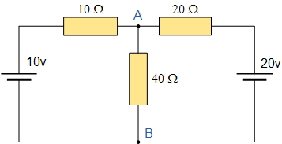

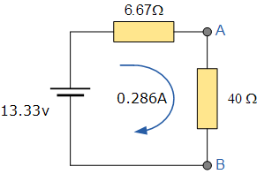

2)

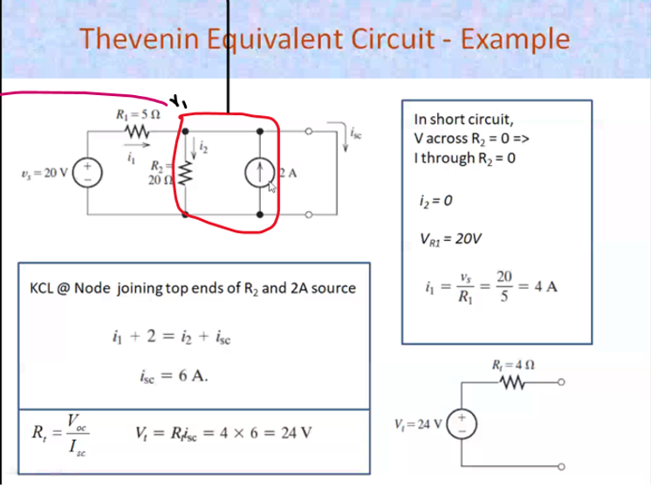



V1-20 + v1 - 2 = 0  
 5 20   
Considering V1 has higher potential (positive) , those all going outside is +ve and coming in is -ve  
NOTE : The circuit must be a open circuit. So remove this



3)

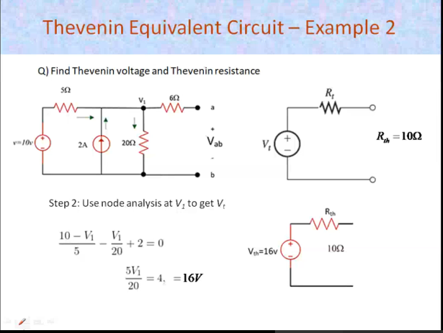

4)

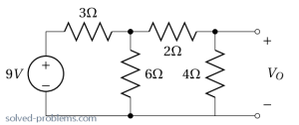 This is the load, we have to remove it while doing the sum



Rth = 4 ohms and Voc = 6V



<http://www.solved-problems.com/circuits/electrical-circuits-problems/1005/thevenins-theorem-circuit-independent-source/>

5)

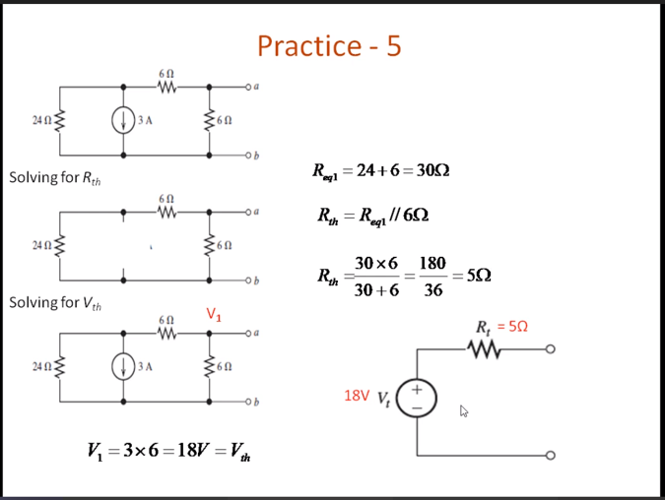



6)

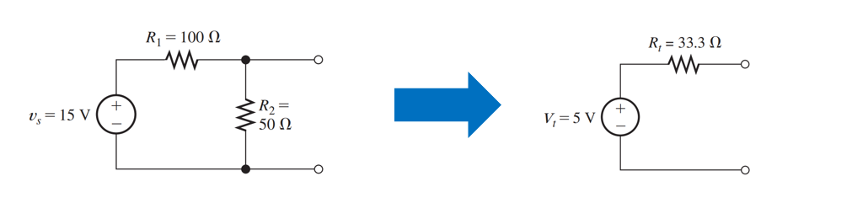

7) Find the Thevenin resistance

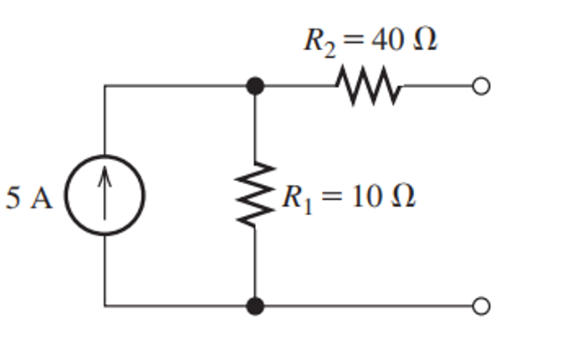



5 + V1 = 0  
 10

V1=-50V

